Client:

Product:

Model:

Version:

Testing Commenced:

Testing Completed:

Results:

Reference:

Overview:

Allen Aircraft Products Inc

6168 Woodbine Rd, Ravenna, OH 44266 · 3

Automated OLS Test Bench

Production Test Tool

Development E03

8/28/2024

8/28/2024

Preliminary Estimate Accuracy & Repeatability

ACCEPTANCE TEST PROCEDURE FOR ALLEN 8005571.05

The purpose this Test is to evaluate the capability of the level calibration procedure as currently implemented.

Summary

Two operators were trained how to calibrate the Automatic OLS Test Bench. After a practice interval, each operator made six (6) calibrations, recorded the resulting M and B (from Mx +B two-point calculation) resulting from each calibration. For each of the last three calibrations, each operator also made a low-level and a high-level measurement compared to an unknow level set point (Blind Measurement).

It is assumed that resulting M & B capture the true accurate level measurement with 95% confidence, while the Blind Measurements capture the system repeatability with 95% confidence, tabulated here.



\*\* Outlier Removed (see analysis)

Conclusion:

1. Uncertainty of absolute level measured is 0.050”
2. Repeatability to entered calibration can be better than 0.005”

Procedure

Two-point calibration method, refer to Figure 1.

1. Run the program, make sure JOG and Sim are OFF
2. Run the calibration routine, Enter Calibrator’s Name,
3. Use the Level SP slider to set Low point then enter the float caliper measurement at that point; then set a Hight point and enter the float caliper measurement at that point. Save the calibration.
4. Record he Cal Coef out M and B values,
5. Blind Point (BP) verification:
6. (5a) Record BP1 by Setting the Level SP (3) to a random BP (Blind Point - Level the measurer doesn't know the value of) then measure and record the caliper measurement and the program reported Level Measurement at this point.
7. (5b). Repeat 5a for BP2.

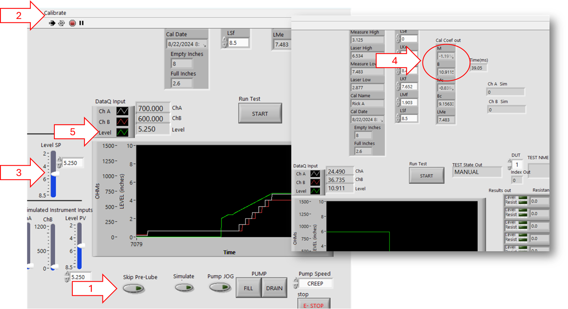

Figure 1

Measurement Process

The Production Manager instructed the two operators in the Level measurement technique using mechanical gage to determine the distance between the bottom to the OLS flange (top of the OLS mounting plate) and the oil surface. It should be noted that the high-level measurement was made with a micrometer while the low-level measurement was made with a caliper.

To calibrate the Automated tester, the calibration dialog asks the operate to set a random low level near empty, make and enter the reading, then set a random low level near empty, make and enter the reading. These reading plus the automatically logged corresponding laser reading are saved in the PC registry. The program uses these values to calculate the M & B calibration coefficients of Mx+B two-point calibration correction. The accuracy of the calibration correction is wholly determined by the accuracy and repeatability of the mechanical measurements entered by the operator.

Calibration Analysis

Since the calibration points are random, it is assumed that a perfect calibration (100% accurate with 0% variation) would result in the same M & B calibration coefficients and the true calibration most likely lies within the M & B 95% confidence limits. This data is tabulated here.



Note:

1. Calibrator 2’s first measurement is not in line with his other 5 measurements. Disregarding that first measurement as an outlier brings his confidence interval in line with operator 1.
2. The difference between the micrometer and caliper seems to have caused a difference between the low and high level measurements?
3. I would appear the true calibration of absolute accuracy lies within 0.050” of the calibrated value using the current system. Further investigation and analysis required?

Repeatability-- Blind Measurements

After each calibration of runs 4-6, a random point was set near full then near empty and the operator measure the level without knowledge to the actual set point or the system level reading, aka the Blind Point Measurement (BP). The results are tabulated here.



Conclusion:

The 95% confidence limit of measurement repeatability can be less than 0.005”

Further Analysis

If the repeatability of measurement is less than 0.005” then why can the calibration coefficients result in a 0.050” uncertainty in absolute level measurement?

Determine if the current calibration and measurement are adequate to evaluate the OLS parts by performing a true Gage R & R study.